

## Topic: Document Details

We have briefly mentioned the **Information** icon and how it can lead you to a document’s **Change History**. This week we’re introducing another feature the **Information** icon includes: **Details**.

You can access a document’s **Details** by clicking on the **Information** icon  either when presented with **Search** **Results** or within the document itself.

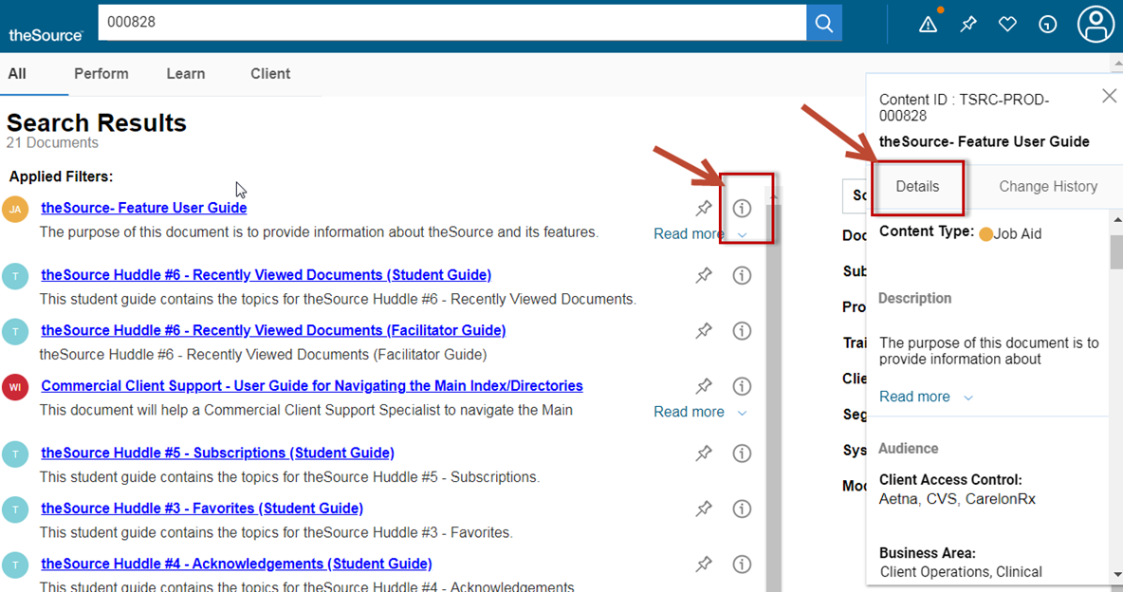 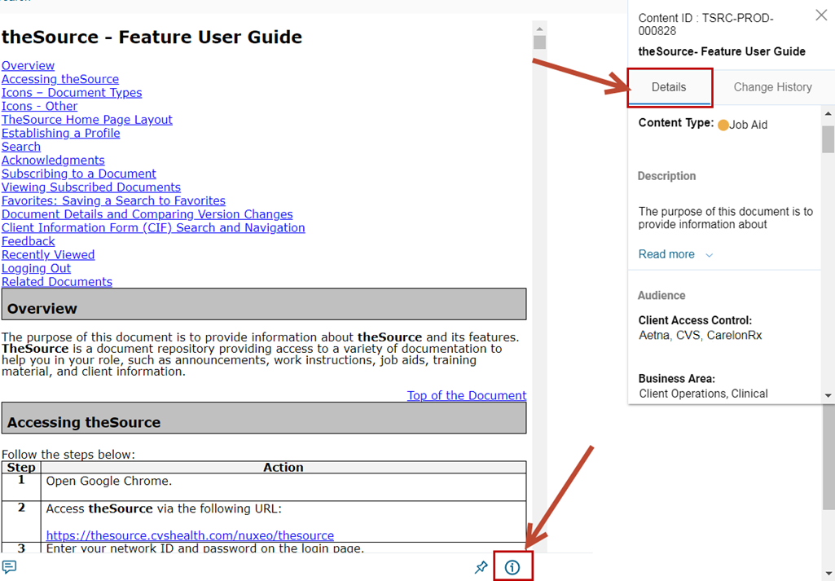

The **Details** tab in the **Information** icon provides information about the document such as:

* Content ID: Each document on theSource has a unique identifier
* Document name
* Content Type: Work Instruction, Training, Job Aid, etc.
* Description: A brief overview of what the document is about
* Audience: Business Area, Department, Line of Business, Position, and Facility
* Classifications: Client (a specific name or type), Systems mentioned in the document (PeopleSafe, RxClaim, etc.), and several others

 Your next challenge on the quest to becoming a Certified theSource Wizard is to utilize the **Details** feature to help you quickly figure out if you’re looking at the right document:

* If you see multiple documents with similar names, read the **Description** to help select the correct document.
* Check the **Audience** to ensure you’ve got your profile set correctly and are seeing the right documents for your position.
* Use the **Classifications** to help narrow your search results.

Not to Be Reproduced or Disclosed to Others without Prior Written Approval

**ELECTRONIC DATA = OFFICIAL VERSION / PAPER COPY = INFORMATIONAL ONLY**